Newsletter | February 2020
Vol 103. No. 1

1129 Queens Avenue, Brandon, MB, Canada R7A 1L9

CONVENTION INFORMATION
HOME AND COUNTRY RAFFLE

Branches are being asked to bring a Basket /Gift (value $35) for the annual Home and Country Raffle.

Please note Receipts for your registration will be included in your registration package. Refund requests will be accepted only with written notification received by the Registrar prior to April 15. _{Registrar}
Debra Barrett
Note prices DO NOT include breakfasts or Friday lunch—these are on your own. | Box 1311
ACCOMMODATIONS | Stonewall MB R0C 2Z0
 | MWI.AGM19@gmail.com
To book a room please call
Stonewall the Rockwood Motor Inn & Motel 204-467-2354, price is approximately $90

OR

Headingly either the Best Western- phone 204-594-2200, price approximately $100 per night or Motel 6 -phone 204-896-9000, price approximately $100 per night

AGENDAS, REGISTRATION FORM AND PROXY FORM PAGES 10 & 11

MWI’S 2020 “Made In Manitoba” Project

This year our “Made in Manitoba” project is being brought back by popular demand. Our focus this year is children and youth, nutrition/health care and poverty.

Donations of hygiene products, socks, gently used footwear, gently used backpacks, toques, mitts and gloves are required.

The Spence Neighbourhood Association working in the west end of Winnipeg provides a Drop-in Centre for youth, called the West End 24 Hours (WE24) at 430 Langside St. This program was started in memory of Tina Fontaine.

One of the services they provide is a hot meal program at midnight, called the Meal Train. Cash donations towards food supplies would be greatly appreciated.

For more information visit https://www.spenceneighbourhood.org/ More information to come!

MWI NEWS February 2020 2

Manitoba Women’s Institute

Executive Administrator: Angela Pickett
1129 Queens Avenue Brandon MB R7A 1L9
204-726-7135 Fax 204-726-6260 mbwi@mymts.net

Provincial Board 2019-2020
President: Denise Joss, Box 1632 Lac du Bonnet R0E 1A0 204-345-5288 awsumden@hotmail.com
President-Elect: Debra Barrett, Box 1311 Stonewall R0C 2Z0 204-467-5777 debramwi@gmail.com
Regional Representatives:

Eastern: Janice Harrison, 48 Waterview Drive La Salle R0G 0A2 204-736-2613 janiceharrison@live.com

Northwest: Marilyn Kippen, 31-11 Davidson Avenue Dauphin R7N 0C5 204-638-7241 kippenmarilyn@gmail.com

Southwest: Sheona Smith, Box 2008 Minnedosa R0J 1E0 204-849-2149 sheonasmith3@gmail.com

Arenda Van Der Deen, Box 156 Rapid City R0K 1W0 204-826-2626 arenda.deen@gmail.com
Wpg.-Interlake: Gisela Nolting, Box 87 Rosser R0H 1E0 204-467-5922 hnolting@mymts.net
Directors-at-Large:

Joan Clement, 302—430 Webb Place Winnipeg R3B 3J7 204-770-9477 deljayfarm@hotmail.com Debbie Melosky, Box 10 Green Ridge R0A 0P0 204-427-2036 wdmelos@xplornet.ca Manitoba Agriculture: Thelma Blahey, Box 2000 Arborg R0C 0A0 204-641-4133

thelma.blahey@gov.mb.ca

WI Canada/FWIC Provincial Representative: Justina Hop, Box 124 Tolstoi R0A 2E0 204-427-2891 blackandwhitecowz@yahoo.com

Manitoba Gov’t Appointed Member: Heather Cummings, Box 522 Neepawa R0J 1H0 204-476-5395 ghcumm1@gmail.com

Mission Statement

“Manitoba Women’s Institute is an organization that focuses on personal development, family agriculture, rural development and community action… locally and globally.”

Vision Statement

Manitoba Women’s Institute strengthens women, families and communities.

MWI NEWS February 2020 3

WI Day – February19th

A Message From Your MWI President - Denise Joss 2018-2020

MWI members have two special days to celebrate in February, Valentine’s Day on February 14th and Women’s Institute Day on February 19th. There will be a brief signing ceremony of the proclamation at the legislature by the Minister Responsible for the Status of Women, the Honourable Catherine Cox on the morning of February 19th.

Angela is looking forward to receiving your pictures and any write-ups that can be posted on our web-site, face-book or mentioned in Twitter. Let her know how your institute celebrated these two exciting days so that we can share with all MWI members.

I hope that you and your and family had a healthy and happy Christmas season. I have been fighting off the virus that only seems to affect your chest and asthma for 8 long weeks. For me, the worst part has been losing my voice a few times and not being able to sing in the church choir. I’m sure that my husband has appreciated some of the quiet time in the house but he has been phoning to check up on me on the days that he was working away from our home. My words were few but the coughing spells were very loud every evening and throughout every single night.

My daughter reminded me that my New Year’s resolution was to take care of myself so I could better help others. I told her that I didn’t make any resolutions. She replied, “I know - so I made that one for you to follow!” If I was to make my own list, I would have “Always remember to be gentle and kind” as Resolution # 1. Our Mary Stewart Collect is our shared reminder before all MWI meetings and events to embrace her words of guidance.

I really grieves me to hear that both cyber and verbal bullying is still happening. The hate messages expressed at rallies, marches, graffiti and on-line continue to offend most Canadians as it should. When I watched the 75th Anniversary of the liberation of those in the concentration camps, I felt that so many people alive today do not understand the consequences of prejudice and fear-mongering.

When you hear and see things occurring that are mean and wrong, please speak-up. You don’t have to say more than “What you just said was wrong and very hurtful.” Remember the days when every-one let your mother know what you did wrong before you even got home from school? My husband gets embarrassed when I see children misbehaving in public and I say, “Stop that now, it’s wrong and you know it”. We need to swing back a little in time to be part of the belief that:
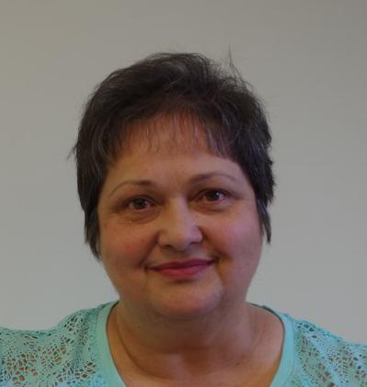

“It takes a village to raise a child.” Together, we are the Village.

“In spite of everything, I still believe people are really good at heart.“ Anne Frank

“All that is necessary for evil to triumph is for good men to do nothing.” Edmund Burke, 1792 British Statesman

MWI NEWS February 2020 4
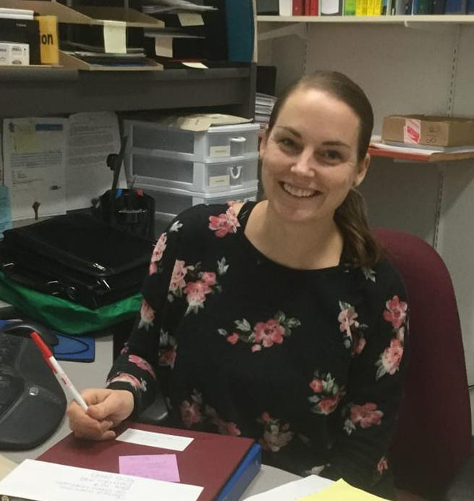

Happy New Year to all of our members!

2019 couldn’t have gone any faster and I can say the same for the Christmas holidays. Now we are in the deep freeze of winter, but already I am looking forward to the spring.

Speaking of spring, soon I will begin work on the Annual Report for the AGM. I will be asking secretaries to send me (by letter or email) a brief one or two paragraphs of WI highlights for your local institute. I thank you all for your timely manner in submitting your year-end reports.

Many updates have been made to the Webpage, and our social media has been a buzz with many WI’s from the UK liking our page and communicating with us through Facebook. It is amazing how small social media can make our world, and bring us closer together. I would love more pictures from your events to post, and add to our digital photo frame.

I have many projects on the go for the Marketing Committee, see our webpage for MWI in Motion, where we will feature local events and maybe even brag a little. Feel free to send me any news worthy happenings from your part of the province!

Until next time,

Angela Pickett, Executive Administrator.

Newsletter

MAIL or E-MAIL??

We have had some MWI members tell us they wish to receive their newsletters by email only instead of mailed. The reasons the members said they preferred emailed only copies are:

1-the emailed version is in colour and more attractive to read,
2-there are no delays due to postal issues,
3-mailed copies are expensive to send out while email is free,

4-emailed copies can be received even when away from home on holidays,

5-mailed copies are made of paper and need to be recycled while emailed copies you just delete,

6-members wanting a copy of specific information in the newsletter can simply print off the page they want to keep.

Those who wish to receive their newsletters by email only please let us know by emailing us at MWI.talks@gmail.com Please include your name and the email address you would like us to use.

Broken pencils are pointless. |  | When you get a bladder infection, urine
 |  | trouble.

MWI NEWS February 2020 5

Manitoba Agriculture Industry Leadership Section is hosting a Learn and Lead Seminar – Human Resources and the Board on March 4 in Brandon. The daylong event will help participants identify human resource factors that affect agriculture organizations.

Protect yourself and your organization

Manitoba Agriculture and Resource Development is hosting a seminar to help participants identify human resource factors in an agriculture organization.

Topics and speakers include:

Ag Action Manitoba Program Highlights

Cathey Day, Manitoba Agriculture and Resource Development

Organization Structure

Leanne Sprung, Manitoba Agriculture and Resource Development

- Defining lines of communications. Speaking for the board.

Laws in Human Resource Management

Janice Goldsborough, The HR Basics

- Overview of legislation that affects human resources

Hiring and Recruiting the Skills You Need

Janice Goldsborough, The HR Basics

Your Role in the Partnership

Joanne Baker, Manitoba Agriculture and Resource Development
- Engaging for a stronger organization

Resolving Conflict Sue Hemphill, Healthy Hive Consulting

- Difficult conversations; tools to build leadership and consensus

Preparing New Employees for Their Position Leanne Tibbatts, Manitoba Agriculture & Resource Development
- Orientation tools, processes and human resource policies

Moderated Discussion: Answering to a Board Manitoba Ag Days General Manager and board members

Moderator – Leanne Sprung, Manitoba Agriculture and
Resource Development

Date | Location | Time
Wednesday, | Riverbank Discovery Centre | Registration is 8:45 a.m.
March 4, 2020 | #1-545 Conservation Drive, Brandon, MB | 9 a.m. to 4 p.m.

Register by February 26, 2020

Facility is accessible. There is a registration fee of $50 per person, which includes lunch and nutrition breaks. Bring your cheque made payable to the Minister of Finance to the workshop. Reserve your spot today by emailing leadership@gov.mb.ca or by calling Manitoba Agriculture and Resource Development at 204-761-2702.

Submitted by Thelma Blahey

Social Media Responses | MWI NEWS February 2020 6

I have been running a WI pen pal exchange for 2 years now. I have had a few ladies from Canada ap-
ply as they have English links. However, the demand is increasing for British ladies to have an over

seas pen pal. We do have a FB page 'UWI pen pal exchange' which has application access on it or la-
dies can email me direct. If you think your members would be interested I could tell you a bit more
about it.
Thank you
Valerie Hughes
President of Sutton WI

Norfolk
England

valerie.hughes08@gmail.com
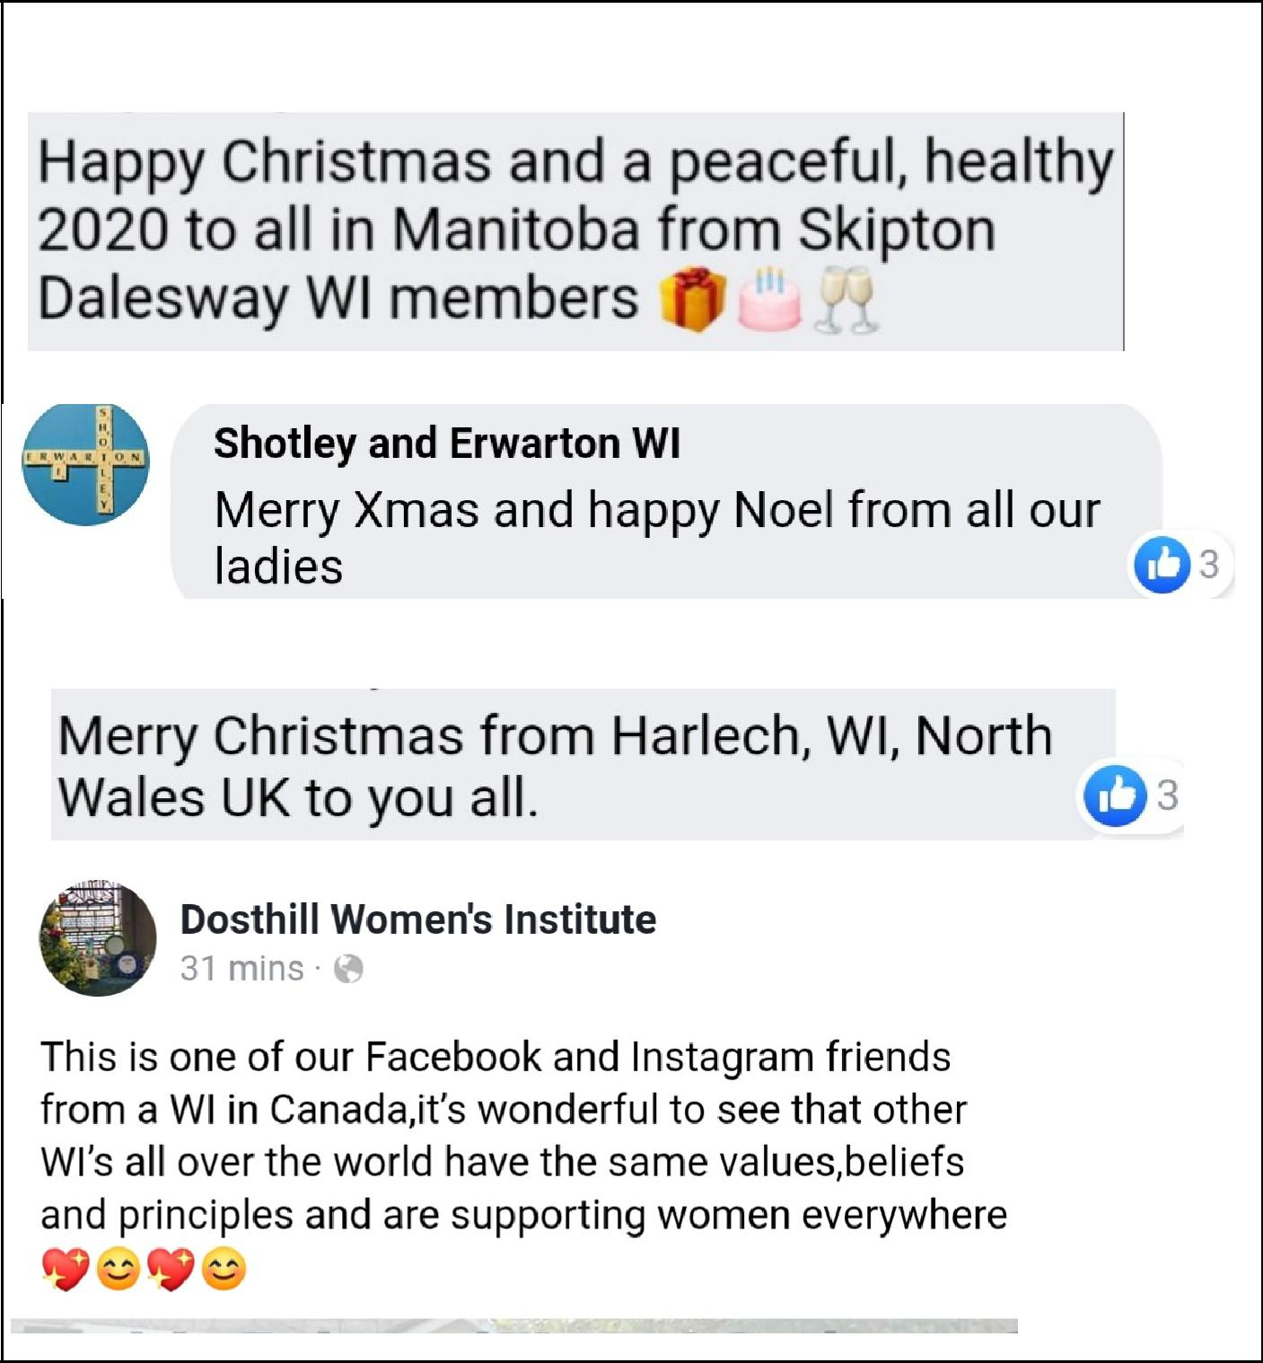

It has been amazing to connect with WI's all around the globe! Check out these greetings from WI's in the United Kingdom!

Note from Ann—love the creative use of Scrabble Tiles in their Photo Circle on their page.

Dosthill’s response
after viewing our

MWI short video on
Facebook.

MWI NEWS February 2020 7

Resolution re: Cell phone coverage in rural Manitoba submitted by Fisher Branch Women’s Institute

Be it resolved that Manitoba Women’s Institute, in solidarity with the Fisher River, Peguis and Jackhead First Nations and the Rural Municipalities of Fisher and Armstrong, recommend the Government of Manitoba and the Canadian Radio-television and Telecommunications Commission (CRTC) require that all telecommunication companies operating in Manitoba provide full cell service and coverage in all rural areas

Background

A great many of Manitoba’s rural areas have little or no cell phone service. For example, in the Interlake region Manitoba Highway 17, a major highway, has zero (0) cell coverage for 47 miles and another area of twenty (20) miles with poor sporadic service. This stretch of highway services a total population in excess of 10,000 people, consisting of the three First Nations communities, seven rural communities and five farming areas. Cell phones in numerous rural areas throughout the province do not work even with cell phone booster assistance. STARS personnel expressed shock when informed that in many rural areas cell coverage is non-existent or sporadic, therefore rendering cell phones virtually useless.

According to the Canadian Radio-television and Telecommunications Commission website, the “CRTC is committed to ensuring that Canadians have access to a world class communications system.” Despite this statement current cell phone coverage is not equitable for all Manitobans and Canadians. In 2017 a BellMTS spokesman stated,” BellMTS has begun our five year, one-billion-dollar investment plan to bring customers across the province faster networks and improved communications services in urban, rural, and remote areas alike. We understand the importance of broad availability and reliability of communications services and note that BellMTS wireless coverage already reaches 97 percent of Manitoba’s populations.” The spokesman further stated, “as is the case for all cellular providers, the costs associated with network expansion in some rural areas are significant and cannot be supported by BellMTS alone. If we can’t make a business case for investment in certain areas, then the solution requires partners.” (Western Producer September 7, 2017) Funding partners tend to be government, communities or other organizations. The one constant is the CRTC, in conjunction with the Manitoba Government, need to assist in ensuring a viable solution is found.

Resolution re: Cell phone inequitable service previously submitted by Fork River WI in 2018

Resolution re: Safe Haven: submitted by Springfield Institute

Be it resolved that Manitoba Women’s Institute (MWI) urges the Government of Manitoba to facilitate an accessible, temporary “Safe Haven” in each Manitoba municipality, through financial support for the training of volunteer teams and the transportation and operating costs for these volunteers to bring rural Manitobans to existing crisis intervention services.

Background:

This resolution has evolved to fill a current need for temporary “Safe Havens” in their communities and the transportation gaps needed to access crisis care. This committee has researched this concern with Crisis centres in Steinbach, Selkirk and Winnipeg, RCMP detachments in Oakbank & Lac du Bonnet, Social Workers in Beausejour & Lac du Bonnet and two Regional Health Authorities.

There is a pressing need in the North-East region of Manitoba, which poses a geographic challenge in terms of territorial size, distance from established crisis and treatment centres and lack of public transportation for families who do not have a vehicle or license to drive. It is our belief that this same need exists in remote areas throughout the Province, a need exacerbated by the closing of all bus lines and the lack of private taxi services. RCMP contacts have confirmed that this situation becomes more pronounced as the distance from Winnipeg increases.

CFS workers expressed a wish for support by having trained volunteers to transport their clients from more remote areas where time and distance prevent Social Workers from being a more effective presence. Often, their clients cannot attend their meetings and access the professional services that they need. This lack of access perpetuates

problems and impedes solutions. Continued on page 8

MWI NEWS February 2020 8

Continued from Page 7

The Crisis Centres indicated their need/desire/mandate is to give priority to clients in their own catchment areas and they confirm our community’s comments that they have been declined services or advised to seek help elsewhere as no space is available at this time. The frequency of declined services given by the Crisis Centres is 2-4 times monthly. These figures are confirmed by Social Workers in Lac du Bonnet.

Most communities have a building that is heated and accessible that could be equipped to provide temporary shelter to a family in crisis. Local governments should be consulted and involved in making plans to identify the operational needs. We believe that these temporary shelters could be supervised and run by “crisis–trained” volunteers. Their services would be activated by the RCMP, Women’s Shelter Staff or Crisis Line Staff by an on-call rotation as the need presents itself.

The Manitoba Women’s Institute feels there is a pressing need to assist with filling in the current gaps in accessing shelter and service for Rural Manitoba Families in need of Crisis Intervention Services. We respectfully ask the Government of Manitoba to address this situation.

This resolution comes from the 29th ACWW Triennial Convention held in 2019
We are asking that it come to the AGM for support purposes:

POLLINATOR PROTECTION

Be it resolved that ACWW societies and members urge their governments and research institutes to contin-ue to identify and reduce specific drivers of insect pollinator decline, develop agricultural pollinator-friendly practices, and promote greater public awareness of the role of insect pollination in global food production. Mover: Country Women’s Council, USA
Seconder: 2nd Florida Association for Home and Community Education, USA
Supporting statement

Pollination is the process of transferring pollen from the male to the female reproductive organs in plants to set seed and produce offspring. As the primary agent for pollination, insect pollinators, both wild and man-aged, are responsible for producing 35% of the food products that humans consume on any given day. In a world of changing environmental conditions, ever-increasing herbicide and pesticide usage, and continuing reduction of natural habitats, these pollinators are experiencing significant population declines. When na-ture’s pollinators go unprotected and uncared for, the world’s food supply is deeply impacted. Source: Con-vention for Biological Diversity; Organisation for Economic Co-operation and Development; Food and Agri-culture Organization of the United Nations; United States Department of Agriculture Farm Services Agency Research tells us there are at least seven diseases and environmental factors which are contributing to the decline of the domestic bee population, Other pollinators such as wild bees, flies, etc. cannot be measured as

easily. There is the possibility of some pollinators and the plants they are pollinating disappearing. (Barret and Kohn – 1991). The value of the bee population in Canada could be $1 – 2 billion or more per year. For our farming lifestyle in Manitoba, we know that crops that could be affected here include alfalfa, canola and others that are not wind pollinated.

SCHOLARSHIPS

MWI invites graduating students to apply for one of TWO one thousand dollar scholarships available again this spring. Application is via an on-line form available on the Red River Ex-hibition web site

http://www.redriverex.com/scholarships/. Applications must be submitted by midnight
Friday May 8th, 2020.

MWI NEWS February 2020 9

Rekindle the Spark of MWI

Do you remember when you joined MWI, the excitement you felt being part of something big,
something new, something unfamiliar?
Do you recall the first few events that you attended, and how it felt to laugh, to share, and to help
others?
In a growing reality of a busier society, it is known that membership will continue to decline if we do
not bring new faces to our organization.

It is time to rekindle the spark of MWI by reminding potential new members what it is that YOU love about our organization and what is has brought to you and your community! So don’t be shy, brag a little, show some photos, encourage them to view our updated web page or social media accounts.

The spark of MWI is still burning strong, and let’s keep that going for many more years to come!

Rekindle: to make someone have a feeling that they had in the past.

NOMINATING COMMITTEE

Want a challenge? Want to contribute to an important organization? Have leadership skills that you are looking to dust off and respond to a challenge? Why don’t you consider putting your name forward to be President Elect of Manitoba Women's Institute?

Do you know of someone who has the skills and abilities to provide leadership? Do you know of one of our members that has ideas to move MWI forward? Why not talk to them and nominate them for the role of President Elect. The successful candidate would serve for two years on the Board and then serves two years as President and one year as Past President, so we are asking a big commitment of the individual.

However, they say behind every great organization there is a great woman with gifts to challenge its membership and to give direction to the organization moving forward into the future. Please give it your consideration. Talk to one of the Committee Ann Mandziuk, Denise Joss or Joan Clement if you require more information. MWI needs you!
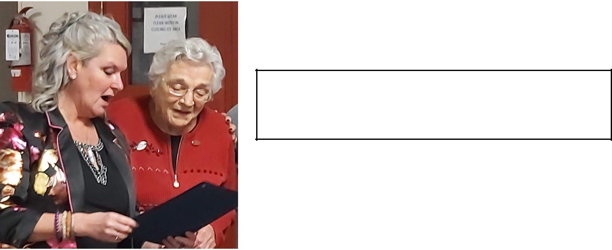

Mary Kubas, Fisher Branch WI receiving her certificate for 60 years of membership and dedicated volunteering to her community.

MWI NEWS February 2020 10

 | MWI PROVINCIAL CONVENTION APRIL 24 & 25, 2020
 |  |  |  | Grosse Isle Community Hall
 |  |  |  | Grosse Isle, Manitoba
Friday April 24, 2020
1:00 | Registration desk opens
1:30 | Coffee and muffins available
2:00 | Chairperson: Denise Joss
 | Welcome
 | Speaker Robin Young, Food Development Centre
 | Topic: Plant Protein Strategy
2:50 | Speaker TBA, Manitoba Habitat Heritage Corporation
 | Topic: Mixing Conservation with Agriculture in Manitoba
 | Development
 | Topic: Manitoba 150
4:30 | Wine & Cheese
5:30 | Banquet
 | Greetings—introduction of special guests
 | Grace
 | Guest speaker: Fiona Jochum, Blue Diamond Farms Ltd.
 | Topic: A Millennial’s Journey: A Journey Around the World
 | and Back to the Farm
8:15 | Entertainment

MWI PROVINCIAL ANNUAL GENERAL MEETING
Saturday April 25, 2020

8:30-9:30 Registration and Verification of Voting Cards
9:30 Welcome and Announcements: Denise Joss
O Canada
12:00-1:00 LUNCH
Chair: Denise Joss
Chair: Debra Barrett
Mary Stewart Collect
Speaker: Ted Meyseton, The Singing
President’s Remarks
Gardner
Introduction of Board
Speaker: Spence Neighbourhood
Parliamentary Procedure
Assoc.
Adoption of Agenda
Election if needed
Roll Call & Attendance Report
Election Report
Voting Strength
MB Agriculture Report—Thelma
Nominations—1st call
Blahey
Approval of Minutes -2019 AGM
Installation of the 2019/20 Board
MWI Annual AGM Report-2018-2019
New Business
Annual Financial Report 2018-2019
BREAK
Nominations—2nd Call
Question Box/Open Mic
BREAK
2021 AGM Plan
Approval of BYLAW 2020
Closing Remarks and Adjournment
Presentation of Resolutions—Janice Harrison
God Save the Queen
Nominations—3rd Call
Photo of the new MWI Board
Nominating Committee Report
4:00 -4:30 Meeting of the new MWI
Introduction of Nominees and Bios
Board

MWI NEWS February 2020 11

Voting Procedures for the 2020 Annual
General Meeting

- The Annual General Meeting (AGM) of Manitoba Women’s Institute will be held Saturday April 25, 2020 in Grosse Isle. Voting for resolutions, elections, annual reports and other motions will be completed at that time.

- Individuals who hold memberships for the current year are eligible to vote. In order to be eligible to vote at the AGM, membership fees must be paid by March 15 of the current year.

- To vote by proxy, members need to complete the proxy form and assign it to another member who is attending the AGM. Both sections of the proxy need to be filled out. A member may carry a maximum of 10 proxies.

- Verification of attending members and proxy votes will be carried out between 8:30 and 9:30 April 25, 2020

- Proxies are not eligible to vote on amendments or amended resolutions.

PROXY VOTE

I, ____________________________, the undersigned, am a cur-rent member of Manitoba Women’s Institute and have eligibility to vote. I assign my voting privileges to be carried by the person named on my In Person Proxy Vote.

Dated at ___________________________ ,

Town

this ________ day of __________________, 2020

Month

________________________________________________________________________

Member's signature

IN PERSON PROXY VOTE
I appoint _____________________________________________

Print full name of proxy carrier
To carry my vote by proxy.

The individual appointed:
- Is currently a member of Manitoba Women’s Institute;
- Will be attending the AGM;

- Has been given this completed form to present for verifica-tion;
- Is able to carry a maximum of ten proxy votes.

Verification of eligibility will be confirmed in advance of the AGM call to order, based on MWI membership records for the current year.

REGISTRATION FORM

Please make cheques payable to MWI 2020 AGM & Convention. Registration deadline April 15, 2020.

NAME ____________________________________ Address ______________________________________

Town _____________________________________ Postal code____________________

Telephone _________________________ e-mail address _________________________________________

Special needs/dietary restrictions/allergies _______________________________________________________

Please check your choices:
Full convention (Friday & Saturday)………..($50) ______________

Friday activities plus evening banquet…….($30) ______________

Friday….Banquet only……………………………..($20)______________

Saturday business meeting……………………..($25) ______________

Registration forms and cheques mailed to:

Debra Barrett

Box 1311

Stonewall MB R0C 2Z0

E-transfer payments to mwi.financial@gmail.com

Note prices DO NOT include

breakfasts or Friday lunch—

these are on your own. To book

a room please call in Stonewall

the Rockwood Motor Inn &

Motel 204-467-2354 or in

Headingly either the Best Western—phone 204-594-2200 or Motel 6—phone 204-896-9000

Coming Events

FEBRUARY 2020
11—Canada’s Agriculture Day
15—Deadline for Erland Lee Award forms

19—Manitoba Women’s Institute Day
27—Adelaide Hunter Hoodless 163rd birthday

MARCH 2020

Canadian Agriculture Literacy Month 8—International Women’s Day
11—MWI Board Meeting (teleconference)

21—International Day for the Elimination of Racial Discrimination

APRIL 2020

1—Newsletter deadline

4—SWA AGM Seniors for Seniors 311 Park Ave. E.

Brandon registration 12:30 meeting 1:15 p.m.
8—MWI Board Meeting (teleconference)
24-25—MWI AGM, Grosse Isle Hall

MAY 2020
27-28—MWI Board Meeting (in person)

JUNE 2020
1—Newsletter deadline

Manitoba Women’s Institute

1129 Queens Avenue
Brandon MB R7A 1L9

MWI NEWS February 2020 12

The Institute News is published six
times per year.
Out-of-province subscription: $40.00
In-province: no subscription
ISBN 1188-0961
Next issue: February 2020
Published by
Manitoba Women’s Institute.
To comment or to make a submission, please send an e-mail to:

mbwi@mymts.net

